ST0249   
AI & Machine Learning

Practical 9  
Bots II



What you will learn / do in this lab

1. Explore Bots concepts and applications

TAble of  
Contents

1. Overview 1

Introduction to Chatbots 1

2. Chatbot Training 2

3. Chatbot Dialog 11

# 1. Overview

In this practical we will be exploring what are chatbots. We will be implementing chatbots using Facebook Messenger and DialogFlow.

## Introduction to Chatbots

Chatbot is a computer program designed to simulate conversations with human users, especially over the Internet.

# 2. Chatbot Training

|  |
| --- |
| Objectives:  After completing this lab, you should be able to:   * Learn how to create intents * Lear how to add user expressions and responses * Learn how to test the Chatbot |

**Scenario**

Management has noted that the company’s customer support is over burdened by responding to the same questions over and over. As a result, they plan to train a bot to help answer FAQ questions and free agents time to work on more complex issues. The FAQ is contained in this address:

<https://www.dbs.com.sg/personal/cards/cards-faqs.page>

**Exercise 1. Create Intents**

Navigate to Dialogflow console [**http://www.dialogflow.com**](http://www.dialogflow.com)

Click **Create Intent -> In the Intent** textbox enter **faq-eligiblity**

In the **User Say’s** enter the information as shown below

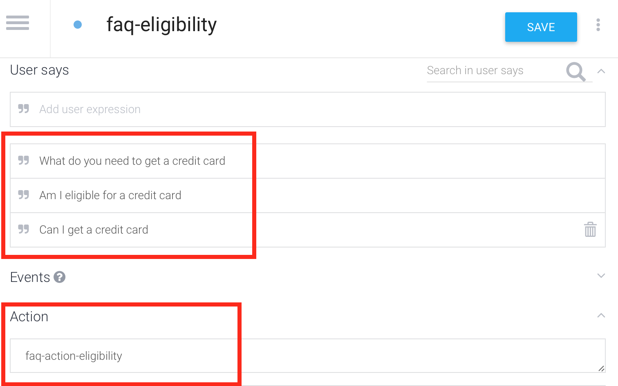

In the **Text response** section type in the following response.

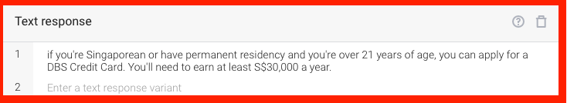

Create another intent. From the side bar tap + button

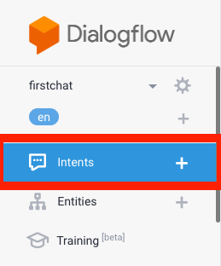

In the **Intent** textbox enter **faq-processingtime**

In the **User Say’s** enter several expressions asking about length of processing. Below is a sample.

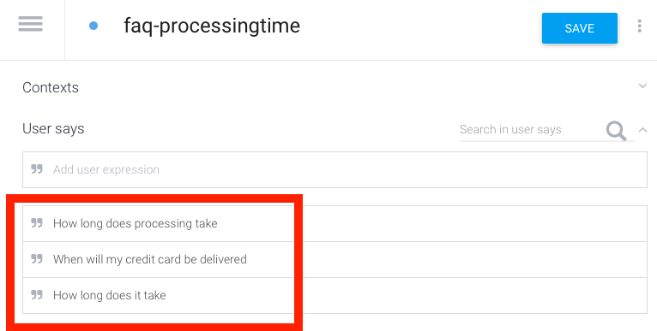

In the **Text response** type in a few responses to the question. Below is a sample.

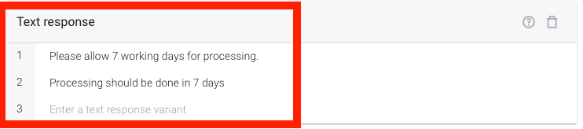

In the **Try it now** textbox type a question to inquire about eligibility or processing time (e.g. Is it possible for me to have a credit card?)

Note the bot response.

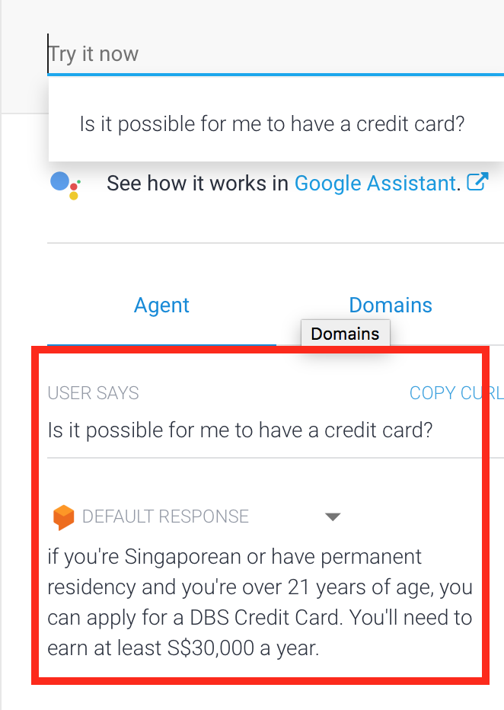

**Exercise 2. Create More Intents**

Add 5 more intents including the user questions/responses. You may select the questions from the provided FAQ or use your own.

**Exercise 3. Using Testers To Make Bot Smarter**

Ask another user to navigate to your Facebook Application. The user must be logged in to his own account.

Let the user send a message such as **Tell me something**. Notice that app does not respond. To make it work, you must add the user as a tester.

To add the user as a tester, navigate to <http://developers.facebook.com>

Click **Roles** -> **Add Testers** -> Type the Facebook ID/Username->Click **Submit** (See below)

Let the user send a message again. The bot should now respond back.

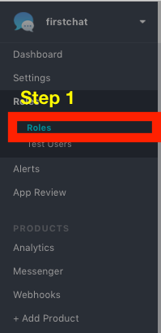

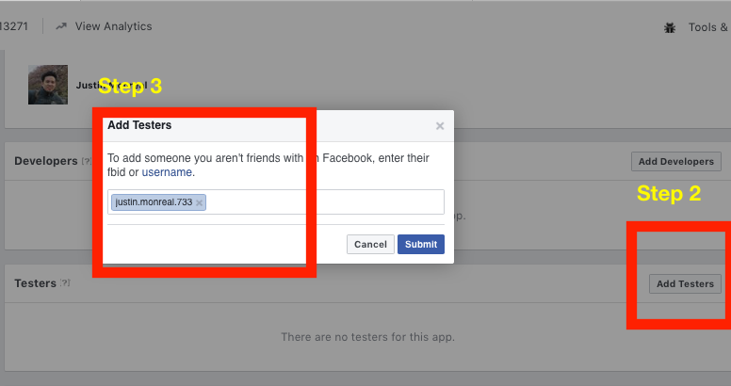

**Exercise 4. Assign Unmatched Requests**

Let the testers send a series of queries to your bot until the bot fails to answer correctly.

After a few incorrect responses, navigate to Dialogflow console <http://console.dialog.com>

In the side bar, click **Training**

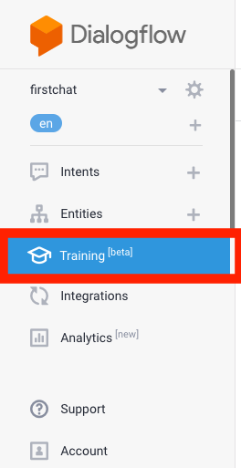

In the dialog, notice some queries are unmatched. Click **Click to assign** andselect the matching intent.

Click **Approve**

Test it out once again. Notice that it recognizes the previously unmatched phrase

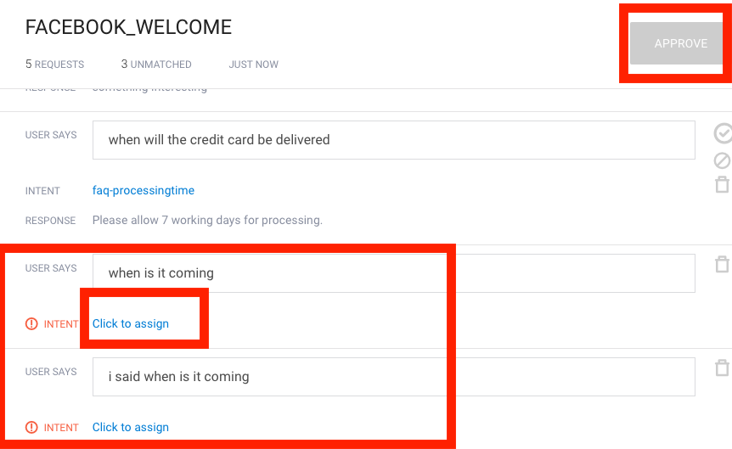

In Dialogflow, click **Intents** in the sidebar. Notice the user expression which was manually assigned is now automatically added to the list of expressions (see below).

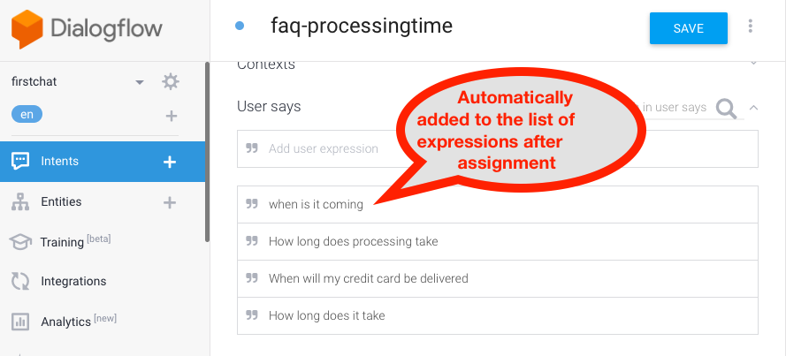

# 3. Chatbot Dialog

|  |
| --- |
| Objectives:  After completing this lab, you should be able to:   * Learn to create Entities * Learn to use Contexts * Learn to label User Expressions with Entities * Learn to create Dialog Conversation |

**Scenario**

Management wants to develop a chatbot pizza ordering service

**Exercise 1. Create Entities**

Navigate to Dialogflow console [**http://www.dialogflow.com**](http://www.dialogflow.com)

From the side bar menu tap **Entities**

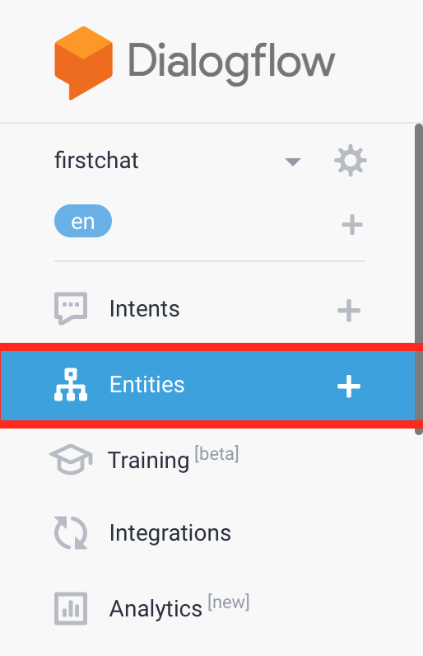

Create the Entity for pizza type name it **pizza-type**:

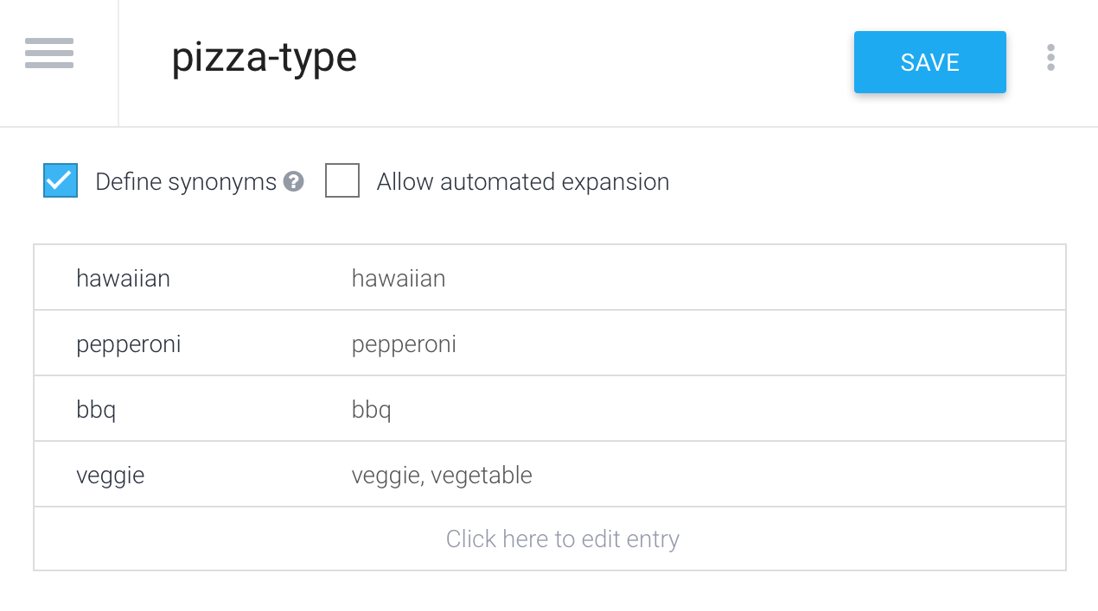

Repeat the process to create the entities for pizza crust, and pizza size as shown below:

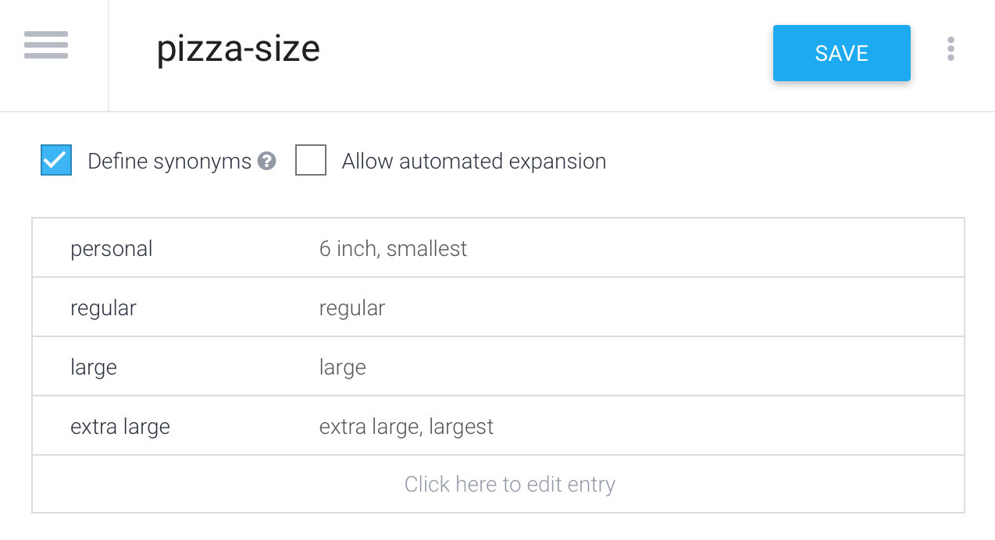

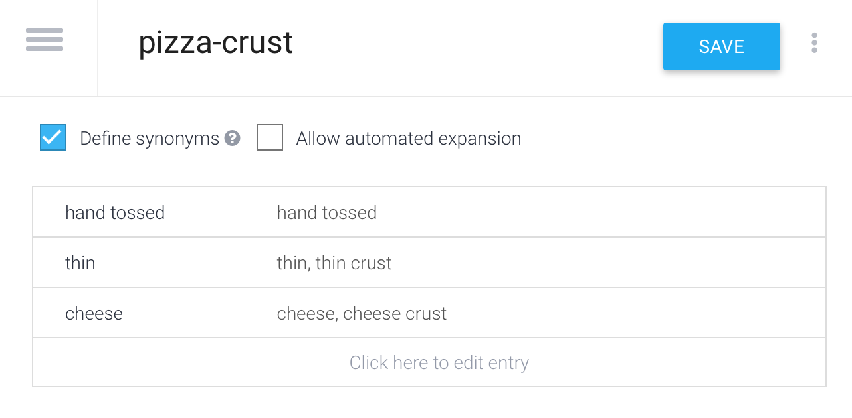

**Exercise 2. Create First Intents**

From the side bar, tap **Intents**

Create an intent by tapping the **Create Intent** button

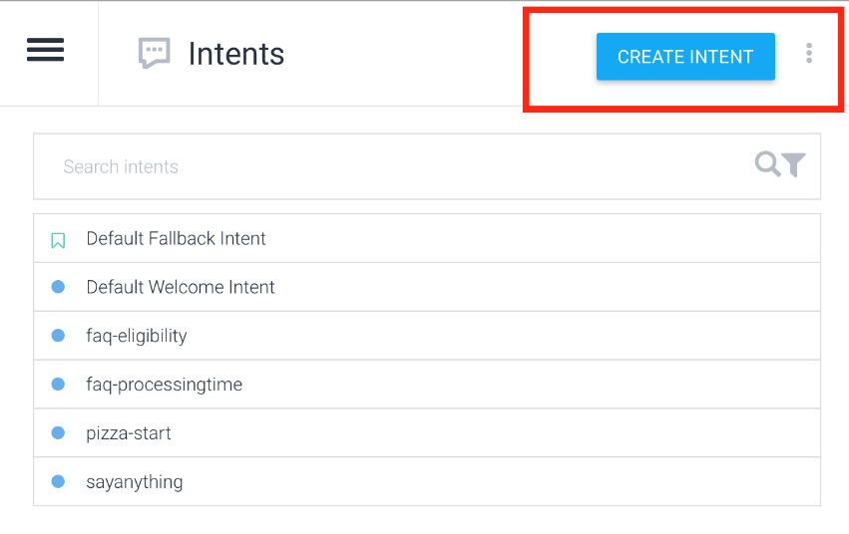

Add an output context **pizza-start**

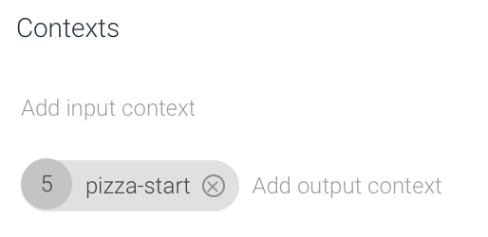

In the **User Says** textbox type a list of user expressions as shown below:

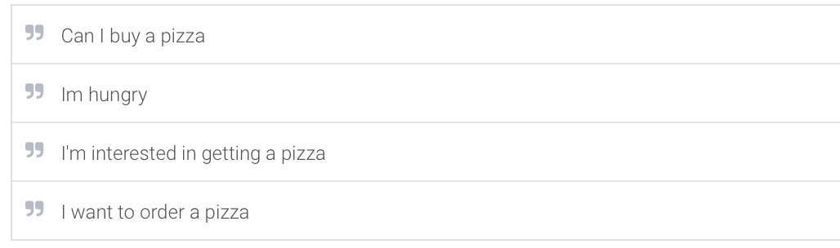

In the **Text Response** section, type a response as below

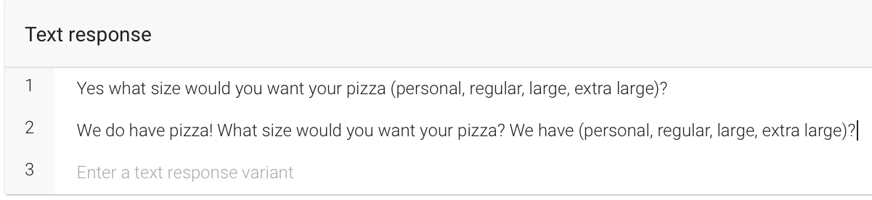

Tap **Save**

**Exercise 2. Create pizza-getsize Intent**

From the side bar, tap **Intents**

Create an intent by tapping the **Create Intent** button

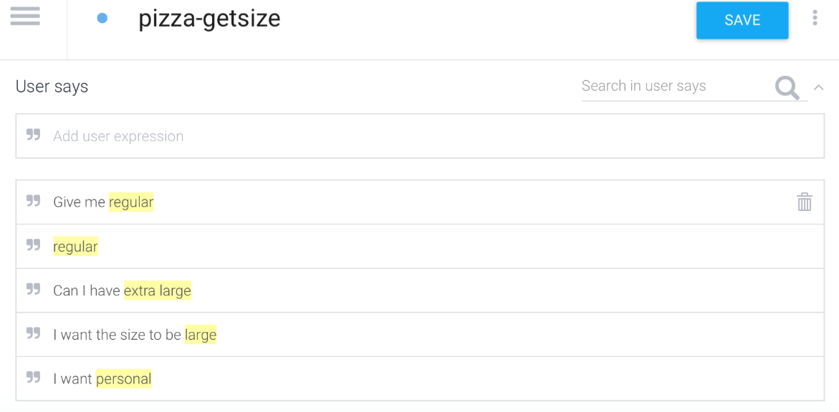

For each expression highlight the size (i.e. regular, large, extra large) and select the **pizza-size** entity from the pop up menu.

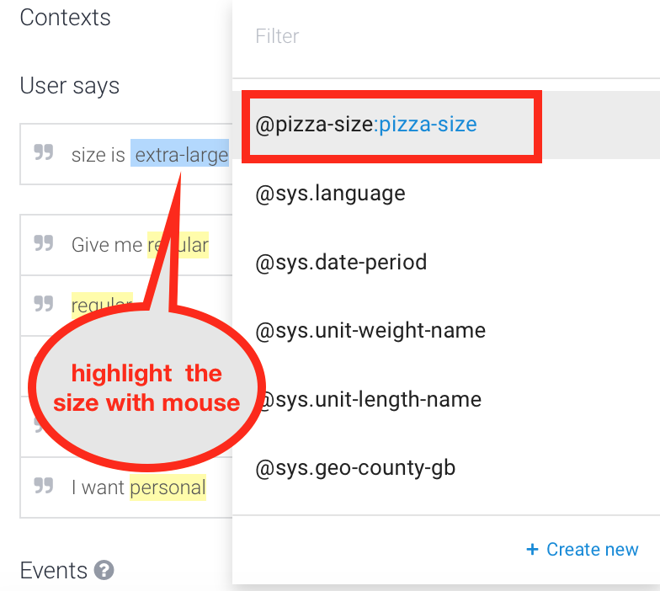

Add an input context as **pizza-start**

Add an output context as **pizza-getsize**

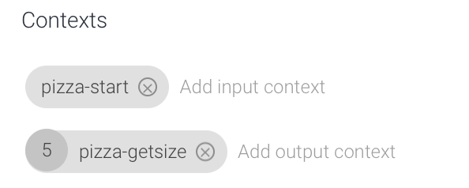

Create text responses as shown below

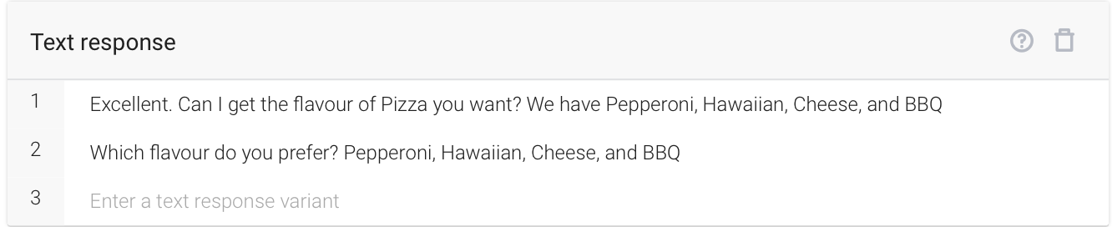

Try Facebook messenger’s **Quick Replies** feature. In the response section, tap facebook_messenger

And add the following quick replies (below)

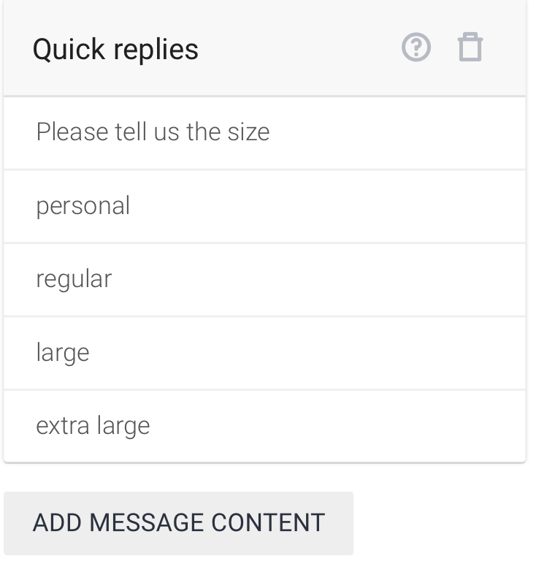

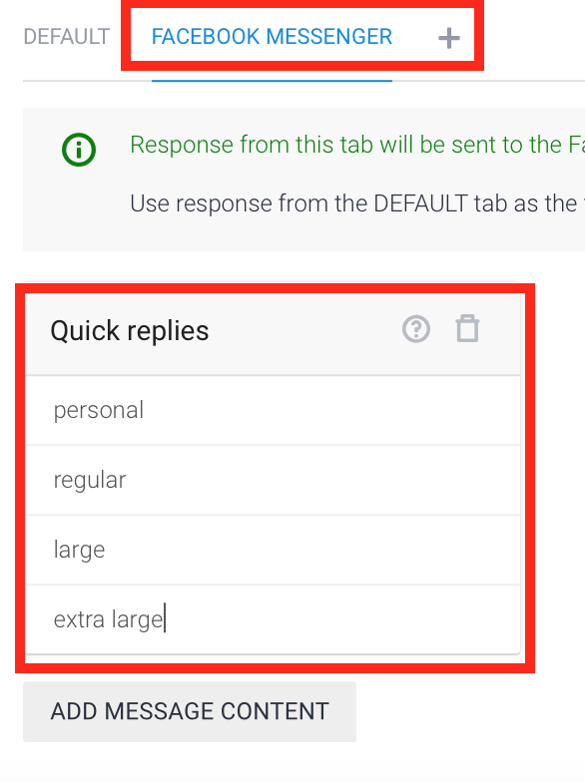

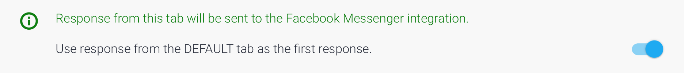

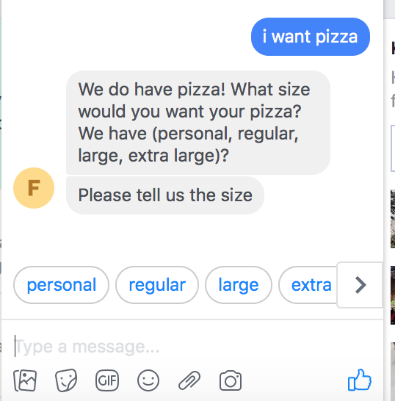

**Exercise 3. Create pizza-getflavour Intent**

From the side bar, tap **Intents**

Create an intent by tapping the **Create Intent** button

Set the contexts as follows:

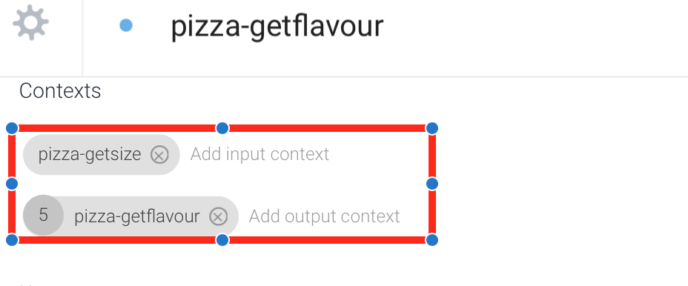

Set the user expressions as follows:

Similar to Exercise 2, label each flavour under the **pizza-type** Entity.

Set the response as follows:

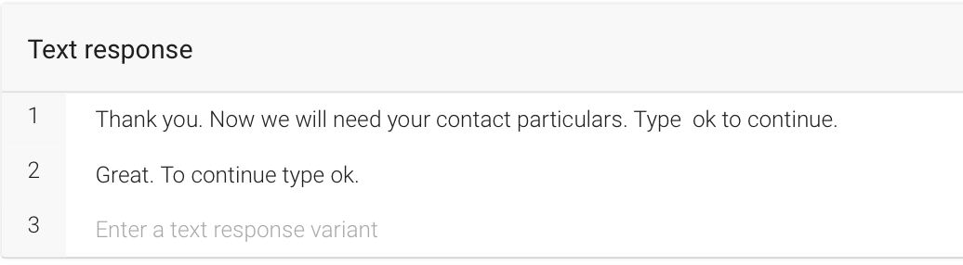

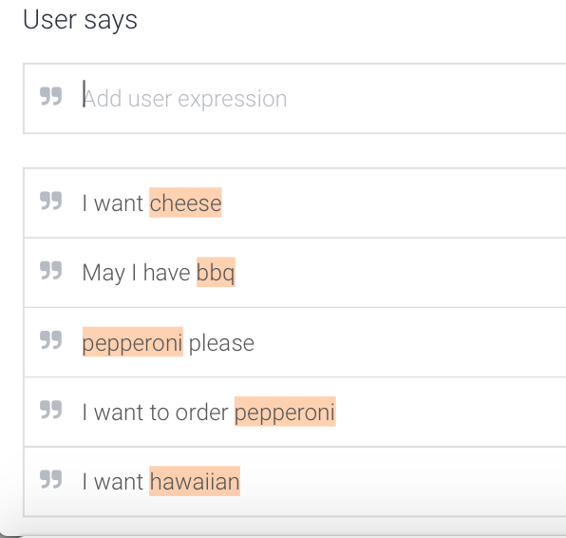

**Exercise 4. Create pizza-user particulars Intent**

From the side bar, tap **Intents**

Create an intent by tapping the **Create Intent** button

Set the contexts and user expression as follows:

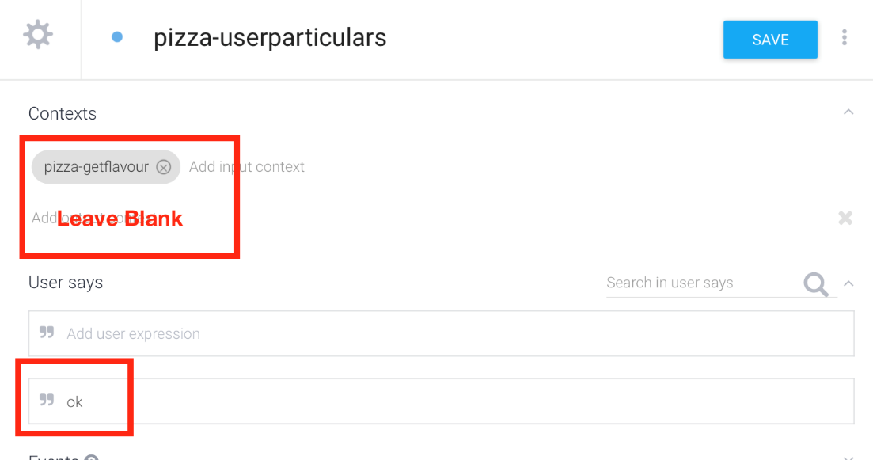

Set the input parameters to retrieve firstname, lastname, phoneno, and postalcode:

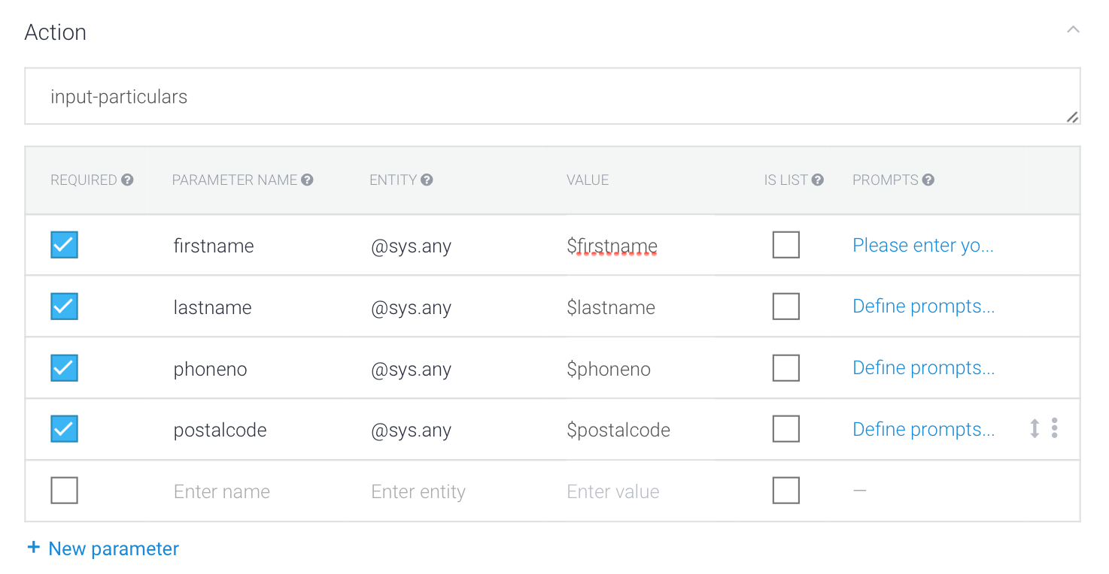

Set the text response as follows:

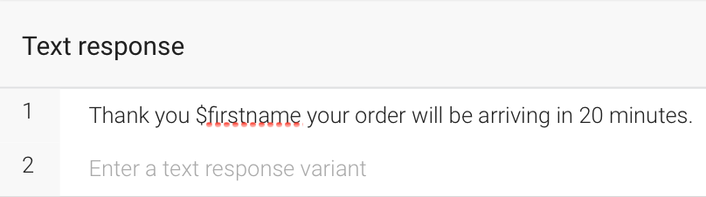

**Exercise 5: Challenge**

**You may try any of the following tasks.**

Modify the pizza chatbot to allow the user to cancel or indicate not interested if the pizza offerings are not desired. The chatbot will respond, thank you. Hope to see you next time.

You are a retailer looking to hire part time workers. Create a jobs application chatbot that will allow the user to apply for three job openings. The chatbot should ask for the following:

* Job being applied for
* The user’s name and age
* The user’s phone number
* The user’s previous job and years of experience
* The user’s previous salary